Why the need for Third Party Risks assessment?
Third-party security assessments are crucial because they provide an unbiased evaluation of an organization’s security posture. These assessments, conducted by Cyberwin, can identify vulnerabilities or weaknesses that internal teams might overlook due to familiarity bias, limited resources, or expertise. By leveraging our perspective, businesses can better safeguard their systems, data, and reputation against potential cyber threats and maintain trust with stakeholders.

Our consultants, with years of expertise, are renowned for conducting and evaluating third-party security assessments on behalf of our esteemed clients. We pride ourselves on our methodology in evaluating third parties’ security controls, leveraging our deep understanding and unparalleled skill set to ensure that third parties’ systems and processes are robust, compliant, and secure.

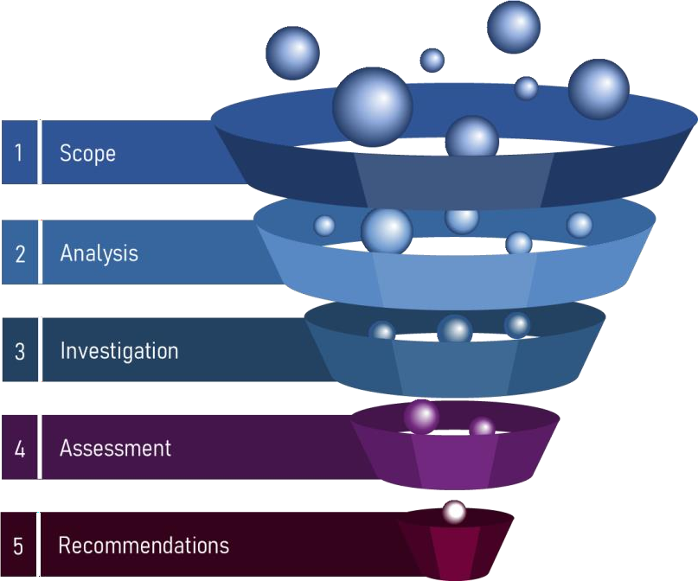
Our Approach

Initiate discussions with the client to fully comprehend the services provided by the third party and the client's specific concerns or focus areas

Analyze the service scope of the third party, identifying key risks associated with the specific services that they deliver to our client and or utilizing Locate Risk capability to identify external vulnerabilities.

Develop tailored security questionnaires and when needed on site visits to the third party for hands on assessment and verification of their practices

Assess the third party based on the provided questionnaire and associated risks, seeking supplementary evidence when required.

Report and present the findings and recommendations to the client, ensuring they have a clear understanding and a roadmap for non- conformities mitigation.

The outcomes

- Third-Party Risk Assessment Report: Comprehensive evaluations and documentation on third-party controls and vulnerabilities, ensuring that clients have a clear picture of potential threats linked to their partners.
- Actionable roadmap for remediation, prioritizing crucial areas.

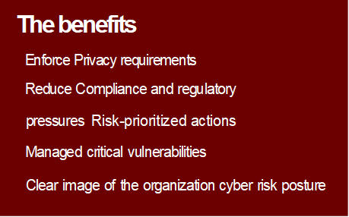

About us

We specialize in assisting C-level executives in navigating the complexity of security governance, risk management and regulatory compliance requirements while bridging the gap between management objectives and technical teams. Our team of consultants and engineers are focused problem solvers with deep technical knowledge and broad industry experience with coverage ranging from government and tier one financial services to telco and mining sectors.

